MedCommons C# CXP SOAP Client

The C# CXP SOAP is a small sample program that demonstrates how to invoke the MedCommons CXP SOAP interface.

Currently only two SOAP interfaces are supported:
- Put(CCR, PIN) – sends a CCR via CXP with a given PIN. The CXP Server returns a status, error messages (if there are errors), and a tracking number.
- Get(TrackingNumber, PIN). Returns the CCR specified by a {tracking number, pin} pair.

This document will be incorporated into the CXP specification.

Installing the program
Unzip the file and open the cxpsoap.csproj in Visual Studio.

Configuring the program
Typically this program does not need to be configured. If you want to point at a host other than
http://127.0.0.1:9080/router/services/CXPServer?wsdl
then follow these steps:
- Open the Solution Explorer and select CXPServer:
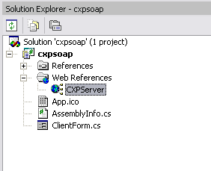
- Right click and select Properties from the menu.
- Enter the URL of the WDSL for the new SOAP endpoint.
- Press Enter. The following dialog box appears:
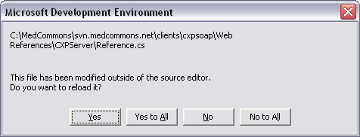
Select “Yes to All”.
- Now press the F5 key to start the debugger. The following window appears:
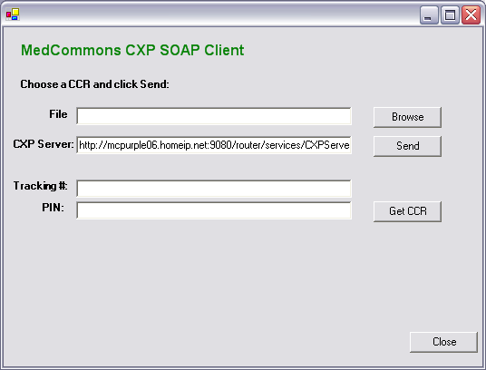
- Click on the browse button to select a CCR, then click the Send button. This transmits the CCR to the server. If the CCR contains validation errors then these will be enumerated in a status display dialog.
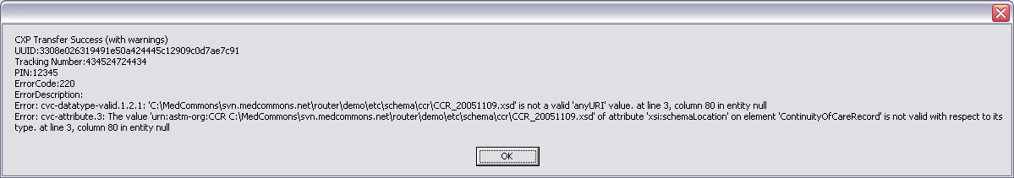
- The application dialog box automatically has the tracking # and PIN filled in:
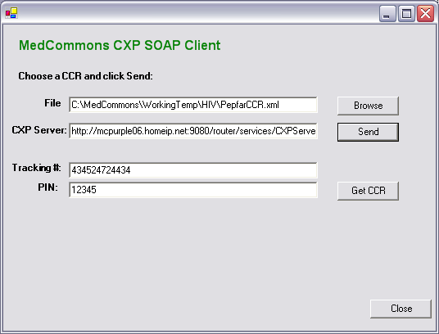
- Clicking the “Get CCR” button will now retrieve the CCR for this tracking number and PIN:
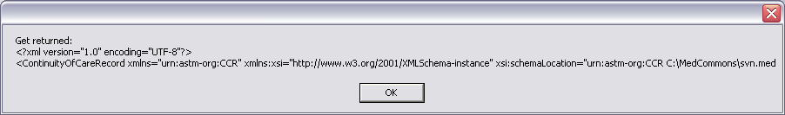
Only the first 200 characters of the CCR are displayed. In a real application the CCR would be saved to disk or would be imported into the application.

